Name: Vishal Jha

Batch: Data Engineering

Date: 19/01/2024

Topic: DDL & DML Commands.

1. Create and use database ‘petadoption’.

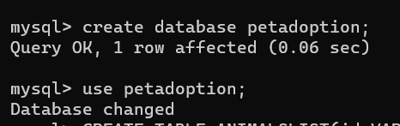

1. Created table animalslist.
2. Inserted values into table animalslist.

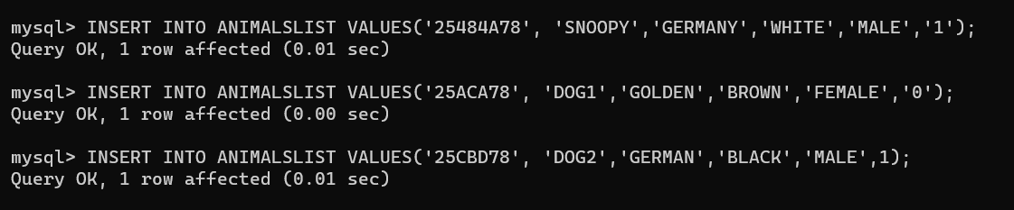

1. View table animalslist.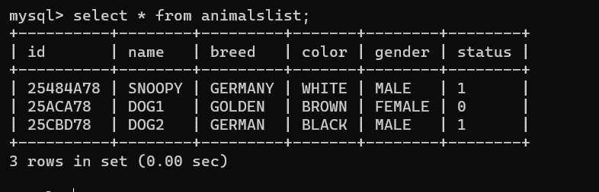
2. Created table adoptions.
3. Inserted value into table adoptions.



1. View table adoptions.

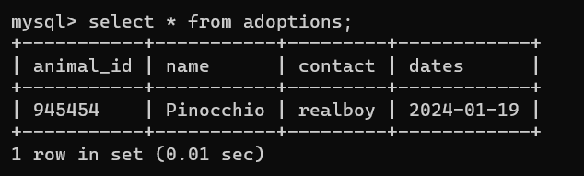

1. Select animal where gender is male.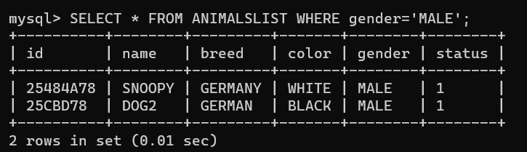
2. Update table animalslist.

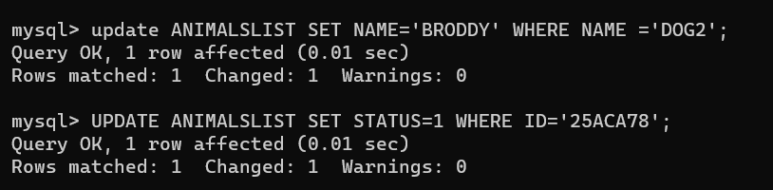

1. Delete a row from table animalslist.

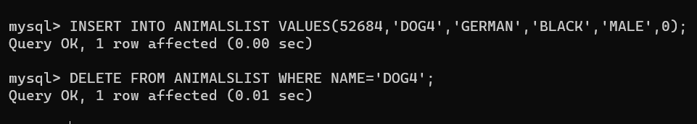

1. Groupby

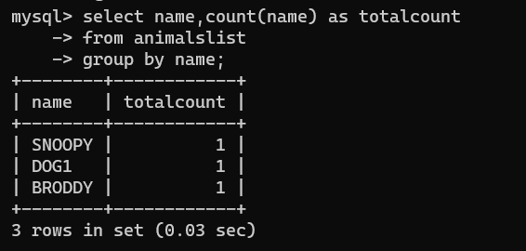

1. Having

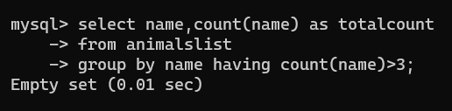

1. Distinct and Orderby

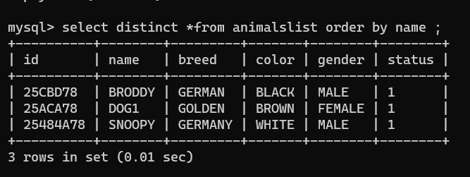

1. Distinct and like

